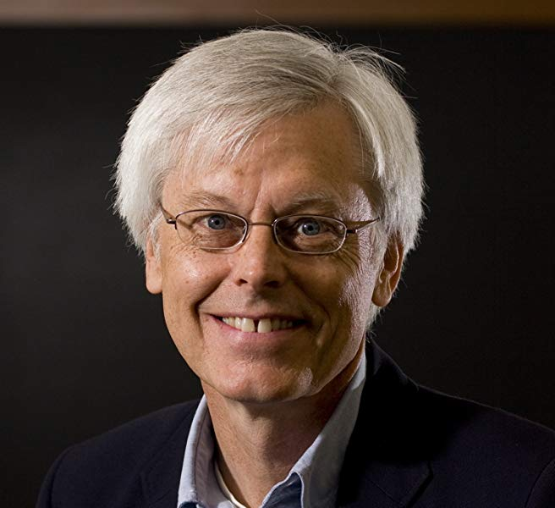
"Science and Clinical Psychology: How to Make Them Allies"
Prof. Dr. Stuart Vyse, Author and independent researcher, USA.

Friday, August, 9th, 2019 - from 9am to 1pm in "Carolina Bori" Auditorium - Bloco G "César Ades" at Institute of Psychology, USP, Campus 'Cidade Universitária', Sao Paolo, SP.
Registration via this link: https://forms.gle/2mRiy8chnvSzumaS6

Prof. Dr. Sturat Vyse will address the challenges to the scientific practice of clinical psychology. His workshop will focus particularly on pseudoscience in autism treatment and pseudoscience in clinical psychology in general, discussing professional responsibilities of therapists with respect to complementary and alternative therapies and clients who believe in them.
The first part of the workshop will cover pseudoscience in autism treatment. Despite the availability of proven science-based treatments, autism continues to attract many pseudoscientific fad therapies. This section will examine why unproven therapies continue to emerge and in some cases are still growing in popularity.
The second part of the workshop will be a discussion of pseudoscience in clinical psychology. He will cover some of these alternative therapies, and the ethical and professional responsibilities of therapists with respect to complementary and alternative medicine therapies and clients who believe in them.
The scientific method is a powerful tool because it has been proved to deliver consistent and useful results which enabled humans to understand and control many aspects of reality. Psychological problems interfere with lives of many individuals and it is among the issues of growing concern in the modern times. The necessity of tackling this problem through a powerful scientific approach is evident and promising.
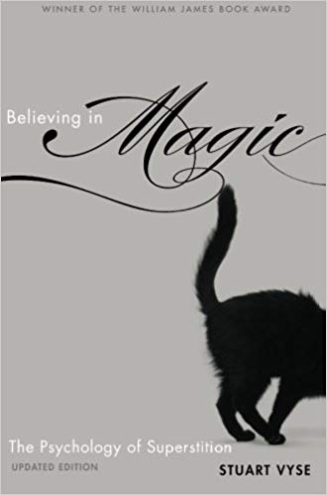
It has taken a very long time for humans to begin to understand their own behavior. For centuries people believed that psychological problems were the work of demons, and we have only recently arrived at a more scientific understanding of human behavior. As a result, scientifically-oriented psychologists are frequently confronted with untested therapies and fad treatments that are promoted by therapists and patients who believe they work. That is why professional clinicians and all those interested in this topic should attend this event.
This workshop will also function as a short graduate course in Experimental Psychology titled PSE5967 "Science and Clinical Psychology: How to Make Them Allies" promoted by the Dept. of Experimental Psychology from the Institute of Psychology at USP. (https://uspdigital.usp.br/janus/componente/disciplinasOferecidasInicial.jsf?action=3&sgldis=PSE5967). Graduate students interested on taking this course for credits should register at the Experimental Psychology Graduate Program. (https://uspdigital.usp.br/janus/componente/disciplinasOferecidasInicial.jsf?action=4&sgldis=PSE5967&ofe=1). The workshop/course will be delivered in English without simultaneous translation.
Prof. Vyse will also deliver a talk titled "Why people believe what they believe" Thursday, August 8th, starting at 2pm in the Institute of Advanced Studies (IEA-USP). Further he will deliver the talk titled "As raízes da superstição" saturday, August 10th, beginning at 9:30am in Livraria Cultura at Paulista Avenue.
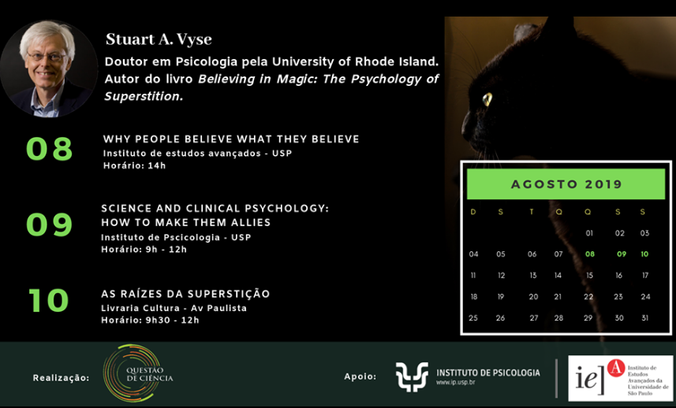

Prof. Stuart Vyse received his Ph.D. in Psychology at the University of Rhode Island, was Professor at the Psychology Dept. in Connecticut College, and recently he is an independent researcher and author of the book Believing in Magic: The Psychology of superstition, and of the online class titled Where do superstitions come from? from the TED Ed's channel on youtube.

Recomended literature:
Vyse, S. (2015, November 23). Psychology's CAM Controversy. Skeptical Inquirer. Retrieved from https://skepticalinquirer.org/exclusive/psychologys_cam_controversy/
Vyse, S. (2016a). Where do fads come from? In R. M. Foxx & J. A. Mulick (Eds.), Controversial Therapies for Autism and Intellectual Disabilities: Fad, Fashion, and Science in Professional Practice, Second Edition(2nd, ed., pp. 3–16). New York: Routledge. https://doi.org/10.4324/9781315754345
Vyse, S. (2016b, April 28). Syracuse, Apple, and autism pseudoscience. Skeptical Inquirer.Retrieved from https://skepticalinquirer.org/exclusive/syracuse_apple_and_autism_pseudoscience/
Vyse, S. (2018a). What’s a therapist to do when clients have pseudoscientific beliefs ? The Behavior Therapist, 41(2), 36–39.
Vyse, S. (2018b, August 07). Autism wars: science strikes back. Skeptical Inquirer.Retrieved from https://skepticalinquirer.org/exclusive/autism_wars_science_strikes_back/
Organization: Profa. Dra. Jaroslava Varella Valentova, Dr. Marco A. C. Varella, e Dra. Natalia Pasternak Taschner.
Offered by the Dept. of Experimental Psychology from the Institute of Psychology at USP in collaboration with Institute of Advanced Studies (IEA-USP), and Institute Question of Science (https://iqc.org.br/).

